Central Pennsylvania HIMSS Presents:
Clinical Informatics, Meaningful Use and the Triple Aim Outlook for 2016
September 18, 2015 9:00am – 3:30pm (Doors open at 8:00)
Hollywood Casino, Grantville, PA

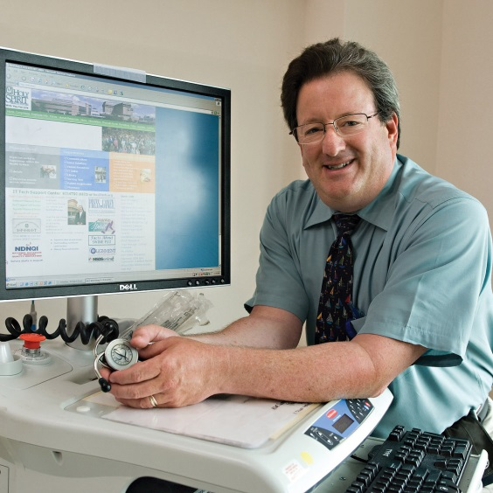
“Why is This EMR Thing so Difficult?”
Presented by:
Dr. Richard Schreiber, Chief Medical Informatics Officer at Holy Spirit Hospital (HSH)—A Geisinger Affiliate—in Camp Hill, PA
PA leaders share their experiences on the following topics:
Patient Engagement panel with representation from the following companies: Get Real Health, St. Luke’s University Health Networks, getwell:)network, Reading Health System, MarkLogic and moderated by Teresa Younkin, Founder/CEO, EHR Explained
Analytics panel with representation from the following companies: Lumeris, Geneia, Medstatix and moderated by William Buddy Gillespie, Director Healthcare Solutions at Distributed Systems Services, Inc
Interoperability panel with representation from the following companies: Stella Technology, NextGen, Caradigm, Cerner, ICSA Labs and moderated by Jim Younkin, Director, Keystone Health Information Exchange (KeyHIE)
PA eHealth Partnership Authority update from David Grinberg, Deputy Director
PA eHealth Partnership Authority update provided by David Gringberg

Join us to learn & network (CME credits offered). Free parking available!
Register Here

